NIM : 32230107
Nama : Steven Setiawan
Diketahui bitmap 24 bit dalam nilai integer sbb:
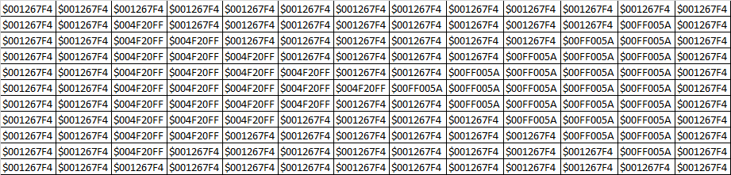

Lakukan kuantisasi terhadap channel R, G dan B jika citra tersebut dikonversi menjadi
- Citra RGB 3 bit dengan nilai threshold 0 s/d 127 menjadi 0 dan 12 s/d 255 menjadi 1
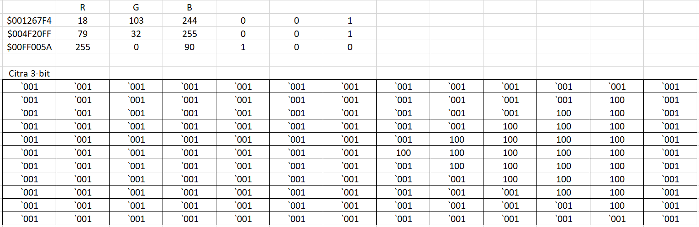
- Citra RGB 8 bit
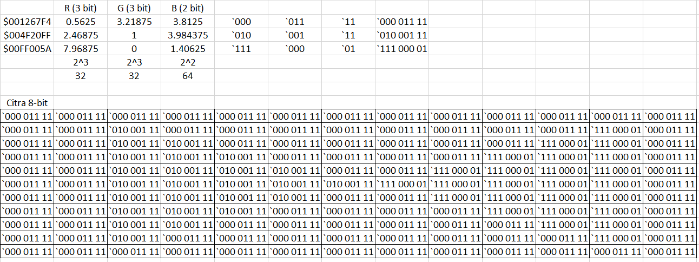

- Citra RGB 16 Bit
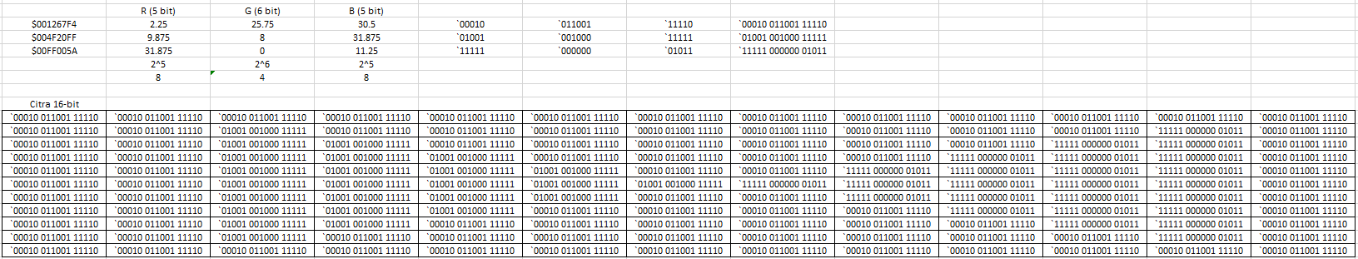
- Ketik program berikut ini, perhatikan bahwa bitmap di ubah menjadi data matrik bertipe integer agar lebih mudah diproses nantinya
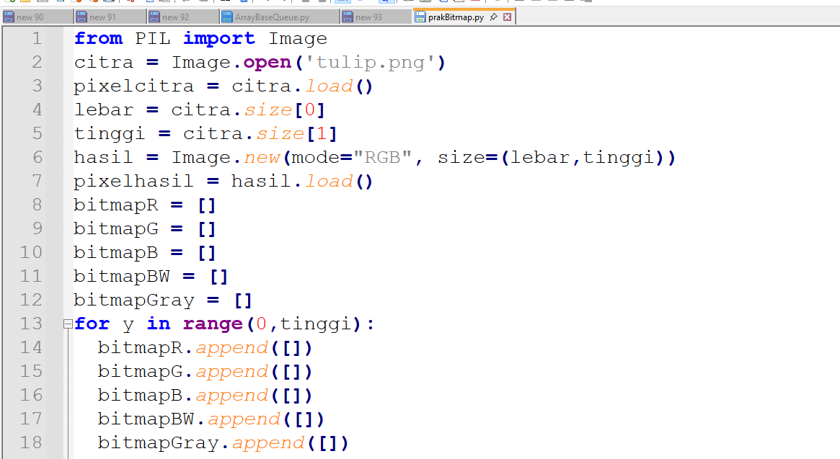
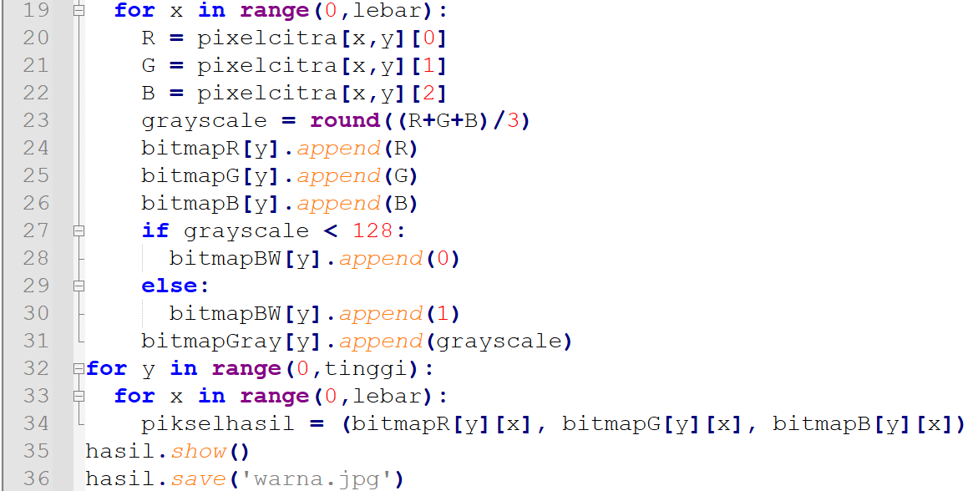
Source Code:
from PIL import Image

citra = Image.open('flower.png')

pixelcitra = citra.load()
lebar = citra.size[0]
tinggi = citra.size[1]
hasil = Image.new(mode = "RGB", size = (lebar, tinggi))
pixelhasil = hasil.load()

bitmapR = []
bitmapG = []
bitmapB = []
bitmapBW = []
bitmapGray = []

for y in range (0, tinggi):
bitmapR.append([])
bitmapG.append([])
bitmapB.append([])
bitmapBW.append([])
bitmapGray.append([])

for x in range(0, lebar):
R = pixelcitra[x, y][0]
G = pixelcitra[x, y][1]
B = pixelcitra[x, y][2]

grayscale = round((R + G + B) / 3)
bitmapR[y].append(R)
bitmapG[y].append(G)
bitmapB[y].append(B)

if grayscale < 128:
bitmapBW[y].append(0)
else:
bitmapBW[y].append(1)
bitmapGray[y].append(grayscale)

for y in range(0, tinggi):
for x in range(0, lebar):
pixelhasil[x, y] = (bitmapR[y][x], bitmapG[y][x], bitmapB[y][x])
hasil.show()
hasil.save('warna.jpg')

Output:
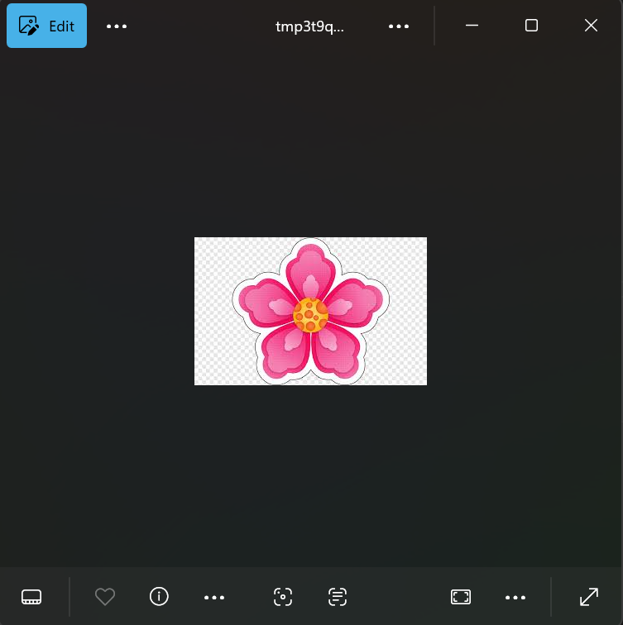
WarnaR:
Source Code:
from PIL import Image

citra = Image.open('flower.png')

pixelcitra = citra.load()
lebar = citra.size[0]
tinggi = citra.size[1]
hasil = Image.new(mode = "RGB", size = (lebar, tinggi))
pixelhasil = hasil.load()

bitmapR = []
bitmapG = []
bitmapB = []
bitmapBW = []
bitmapGray = []

for y in range (0, tinggi):
bitmapR.append([])
bitmapG.append([])
bitmapB.append([])
bitmapBW.append([])
bitmapGray.append([])

for x in range(0, lebar):
R = pixelcitra[x, y][0]
G = pixelcitra[x, y][1]
B = pixelcitra[x, y][2]

grayscale = round((R + G + B) / 3)
bitmapR[y].append(R)
bitmapG[y].append(G)
bitmapB[y].append(B)

if grayscale < 128:
bitmapBW[y].append(0)
else:
bitmapBW[y].append(1)
bitmapGray[y].append(grayscale)

for y in range(0, tinggi):
for x in range(0, lebar):
pixelhasil[x, y] = (bitmapR[y][x], 0, 0)
hasil.show()
hasil.save('warnaR.jpg')
Output:
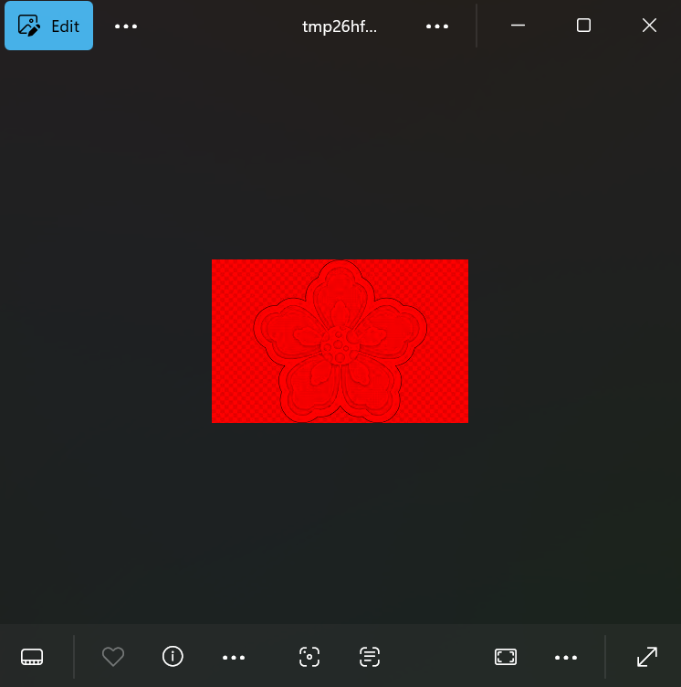
WarnaG:
Source Code:
from PIL import Image

citra = Image.open('flower.png')

pixelcitra = citra.load()
lebar = citra.size[0]
tinggi = citra.size[1]
hasil = Image.new(mode = "RGB", size = (lebar, tinggi))
pixelhasil = hasil.load()

bitmapR = []
bitmapG = []
bitmapB = []
bitmapBW = []
bitmapGray = []

for y in range (0, tinggi):
bitmapR.append([])
bitmapG.append([])
bitmapB.append([])
bitmapBW.append([])
bitmapGray.append([])

for x in range(0, lebar):
R = pixelcitra[x, y][0]
G = pixelcitra[x, y][1]
B = pixelcitra[x, y][2]

grayscale = round((R + G + B) / 3)
bitmapR[y].append(R)
bitmapG[y].append(G)
bitmapB[y].append(B)

if grayscale < 128:
bitmapBW[y].append(0)
else:
bitmapBW[y].append(1)
bitmapGray[y].append(grayscale)

for y in range(0, tinggi):
for x in range(0, lebar):
pixelhasil[x, y] = (0, bitmapG[y][x], 0)
hasil.show()
hasil.save('warnaG.jpg')
Output:
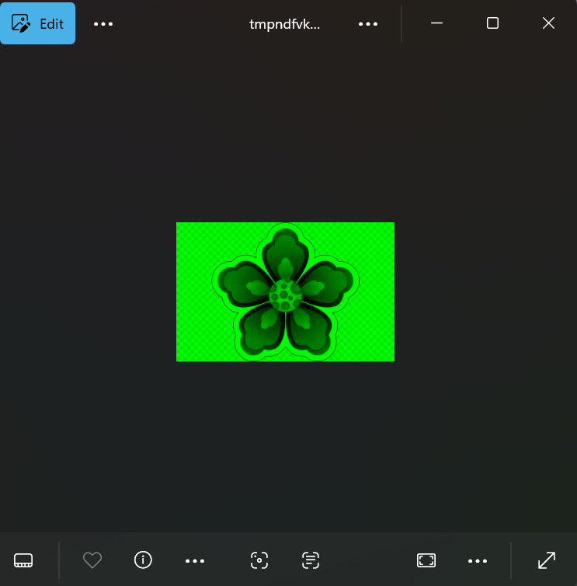
WarnaB:
Source Code:
from PIL import Image

citra = Image.open('flower.png')

pixelcitra = citra.load()
lebar = citra.size[0]
tinggi = citra.size[1]
hasil = Image.new(mode = "RGB", size = (lebar, tinggi))
pixelhasil = hasil.load()

bitmapR = []
bitmapG = []
bitmapB = []
bitmapBW = []
bitmapGray = []

for y in range (0, tinggi):
bitmapR.append([])
bitmapG.append([])
bitmapB.append([])
bitmapBW.append([])
bitmapGray.append([])

for x in range(0, lebar):
R = pixelcitra[x, y][0]
G = pixelcitra[x, y][1]
B = pixelcitra[x, y][2]

grayscale = round((R + G + B) / 3)
bitmapR[y].append(R)
bitmapG[y].append(G)
bitmapB[y].append(B)

if grayscale < 128:
bitmapBW[y].append(0)
else:
bitmapBW[y].append(1)
bitmapGray[y].append(grayscale)

for y in range(0, tinggi):
for x in range(0, lebar):
pixelhasil[x, y] = (0, 0, bitmapB[y][x])
hasil.show()
hasil.save('warnaB.jpg')
Output:
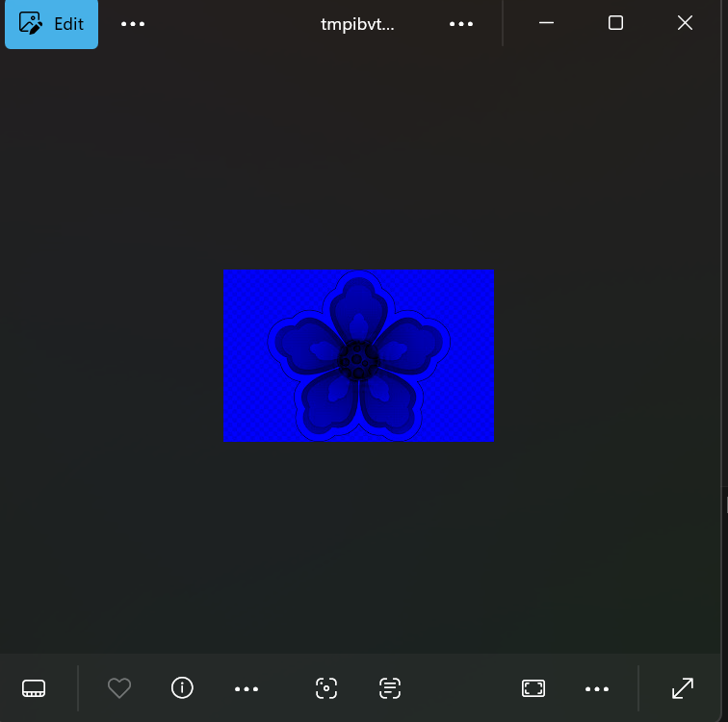
BW:
Source Code:
from PIL import Image

citra = Image.open('flower.png')

pixelcitra = citra.load()
lebar = citra.size[0]
tinggi = citra.size[1]
hasil = Image.new(mode = "RGB", size = (lebar, tinggi))
pixelhasil = hasil.load()

bitmapR = []
bitmapG = []
bitmapB = []
bitmapBW = []
bitmapGray = []

for y in range (0, tinggi):
bitmapR.append([])
bitmapG.append([])
bitmapB.append([])
bitmapBW.append([])
bitmapGray.append([])

for x in range(0, lebar):
R = pixelcitra[x, y][0]
G = pixelcitra[x, y][1]
B = pixelcitra[x, y][2]

grayscale = round((R + G + B) / 3)
bitmapR[y].append(R)
bitmapG[y].append(G)
bitmapB[y].append(B)

if grayscale < 128:
bitmapBW[y].append(0)
else:
bitmapBW[y].append(1)
bitmapGray[y].append(grayscale)

for y in range(0, tinggi):
for x in range(0, lebar):
pixelhasil[x, y] = (bitmapBW[y][x]*255, bitmapBW[y][x]*255, bitmapBW[y][x]*255)
hasil.show()
hasil.save('biner.jpg')
Output:
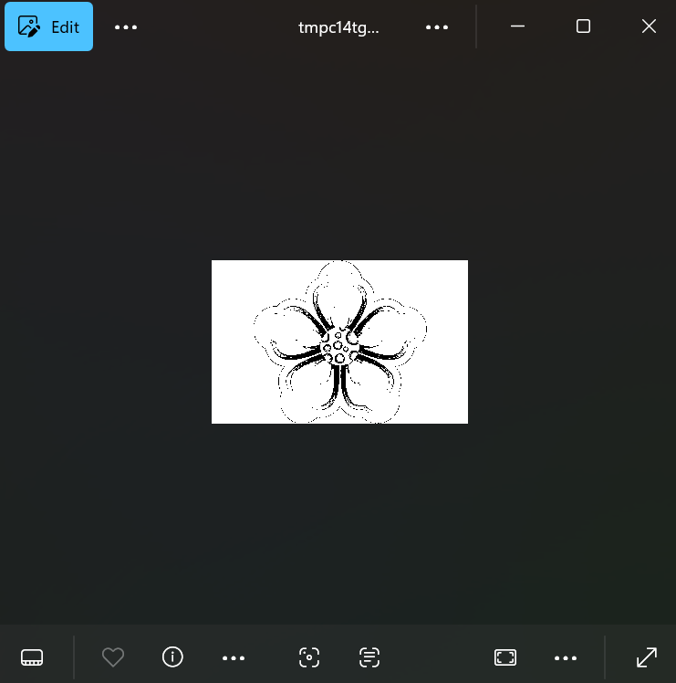
Grayscale:
Source Code:
from PIL import Image

citra = Image.open('flower.png')

pixelcitra = citra.load()
lebar = citra.size[0]
tinggi = citra.size[1]
hasil = Image.new(mode = "RGB", size = (lebar, tinggi))
pixelhasil = hasil.load()

bitmapR = []
bitmapG = []
bitmapB = []
bitmapBW = []
bitmapGray = []

for y in range (0, tinggi):
bitmapR.append([])
bitmapG.append([])
bitmapB.append([])
bitmapBW.append([])
bitmapGray.append([])

for x in range(0, lebar):
R = pixelcitra[x, y][0]
G = pixelcitra[x, y][1]
B = pixelcitra[x, y][2]

grayscale = round((R + G + B) / 3)
bitmapR[y].append(R)
bitmapG[y].append(G)
bitmapB[y].append(B)

if grayscale < 128:
bitmapBW[y].append(0)
else:
bitmapBW[y].append(1)
bitmapGray[y].append(grayscale)

for y in range(0, tinggi):
for x in range(0, lebar):
pixelhasil[x, y] = (bitmapGray[y][x], bitmapGray[y][x], bitmapGray[y][x])
hasil.show()
hasil.save('grayscale.jpg')
Output:
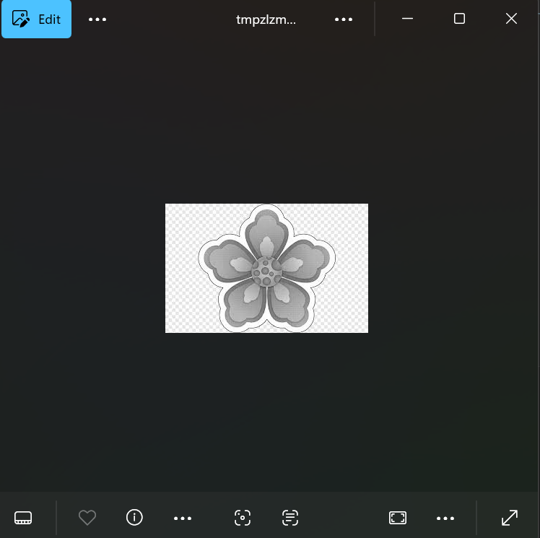
- Buatlah program untuk melakukan kuantisasi warna RGB 24 ke RGB 3 bit, RGB 8 bit dan RGB 16 bit
Source Code:
from PIL import Image

citra = Image.open('flower.png')
pixel = citra.load()
lebar, tinggi = citra.size

hasil3 = Image.new("RGB", (lebar, tinggi))
p3 = hasil3.load()

for y in range(tinggi):
for x in range(lebar):
R, G, B = pixel[x, y]

Rq = R // 128
Gq = G // 128
Bq = B // 128

p3[x, y] = (Rq * 255, Gq * 255, Bq * 255)

hasil3.save("rgb_3bit.png")
hasil3.show()

hasil8 = Image.new("RGB", (lebar, tinggi))
p8 = hasil8.load()

for y in range(tinggi):
for x in range(lebar):
R, G, B = pixel[x, y]

Rq = R // 32
Gq = G // 32
Bq = B // 64

p8[x, y] = (Rq * 32, Gq * 32, Bq * 64)

hasil8.save("rgb_8bit.png")
hasil8.show()

hasil16 = Image.new("RGB", (lebar, tinggi))
p16 = hasil16.load()

for y in range(tinggi):
for x in range(lebar):
R, G, B = pixel[x, y]

Rq = R // 8
Gq = G // 4
Bq = B // 8

p16[x, y] = (Rq * 8, Gq * 4, Bq * 8)

hasil16.save("rgb_16bit.png")
hasil16.show()

Output:
